

**Can you help her find her ?**

**Maple lost her best friend Jessie.**



**You did it!**

**Maple found Jessie!**

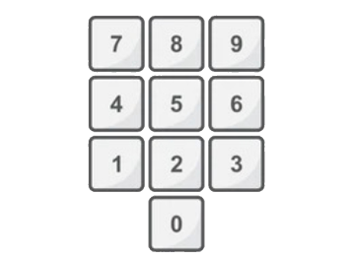

**This is Maple : and this is Jessie :**

**Maple lost her friend Jessie. Your goal is to help Maple solve the maze and find Jessie.**

**In order to search the maze, you can use the numpad**

**You can also click on Maple and drag her around the maze .**

**You can move in regular and diagonal directions.**

**Please be aware of the maze walls Maple cannot go through them.**

**If you are having trouble solving the flower maze, just click the "Solve Maze" button.**

**The road look like this - while the solution will look like this - .**

**In the menu bar above the game, you can click "file" in order to:**

* **New : Enter row and column as you like 😊 (should be greater than 1) .**
* **Load : Open an existing maze file .**
* **Save : Save the current maze to your computer.**

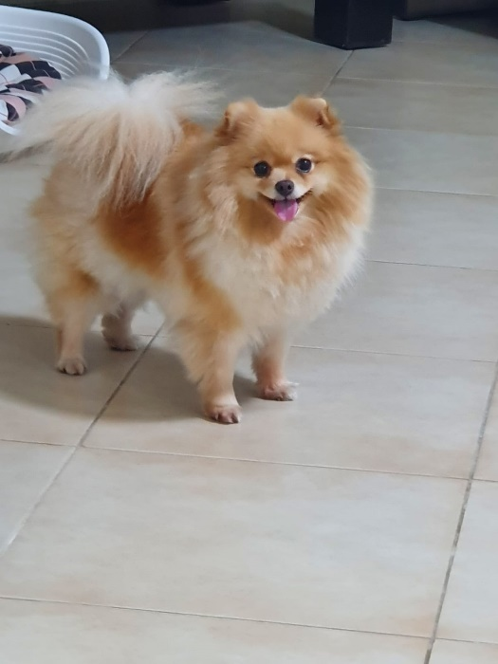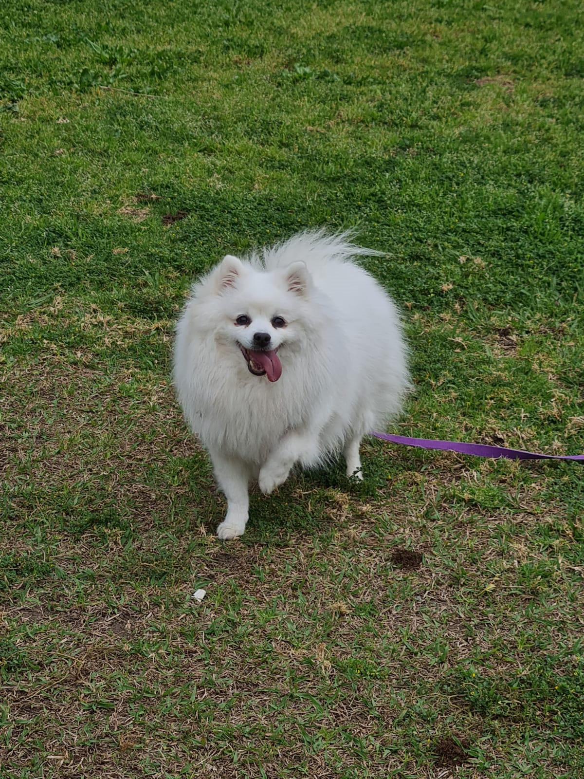



The actors : (our dogs)

Maple the Pomeranian

Jessie the Japanese Spitz

The programmers : Shiri Itach , Noam Cohen Maguri

Software and Information Systems Engineering

The algorithms used :

Generation - "MyMazeGenerator", which implements the Prim's Maze Generator

Solving – "BreadthFirstSearch" , "DepthFirstSearch" , "BestFirstSearch"



